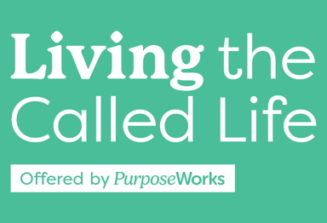
Week 7, April 3, Spring 2025 Lesson Plan
Get Name Tags with markers out for name tag exercise

7:00-7:03 3min Becky Welcome, Prayer
7:03-7:13 10 min Becky Name Tag: “I help people…” exercise, share in Cohort, a couple people share larger group
7:13-7:25 12min Craig? Homework Check-in & Large Group Discussion
7:25-7:31 6 min Craig Recap of 7 Blackaby points, Obedience, Adjustments
7:31-7:51 20m Becky Stop, Start, Continue of Growth Plan, 7 Teaching + 13m to work
7:51-7:56 5 min Becky Life Growth Plan Putting it all together- 2 views on my life- My view from Above (Oaks/Boxes); My view from Street Level – moving forward
7:56-8:09 13 min Becky Presentation Directions, include Q&A, Joanna testimony (5)
8:09-8:10 1 min Craig Homework Review for week 8
8:10-8:20 10 min Craig Dream Together (3)
8:20-8:22 2min Craig Mission Exploration Spotlight - Disaster
8:22-8:26 4min Craig Closing – Prayer – Encourage to come next week
8:26-8:45 19 min Craig Cohort discussion on Questions on slide/handout re: book
Handout Contents:
1 Cover Sheet
2 Key Slides – 6-11,15,21,23,24, 30 = 11 slides, 6 to a page
3 LTCL 8 areas Stop, Start, Continue (Providing as WORD doc to fill out?)
4 Life Calling Wheel Suggested Activities
5 Oaks of Righteousness (Providing as WORD doc to fill out)
6 My Life Growth Plan page 1(Providing as WORD doc to fill out)
7 My Life Growth Plan page 2(Providing as WORD doc to fill out)
8 Presentation Directions
9 Sample LTCL Life Calling Plan

