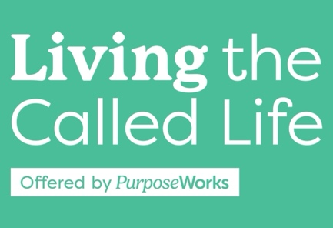

**S.H.A.P.E. Experience: Life Wins / Struggles**

Personal Wins:

Career Wins:

Past Hurts / Life Struggles:

Spiritual Highlights:

Unique Experiences: