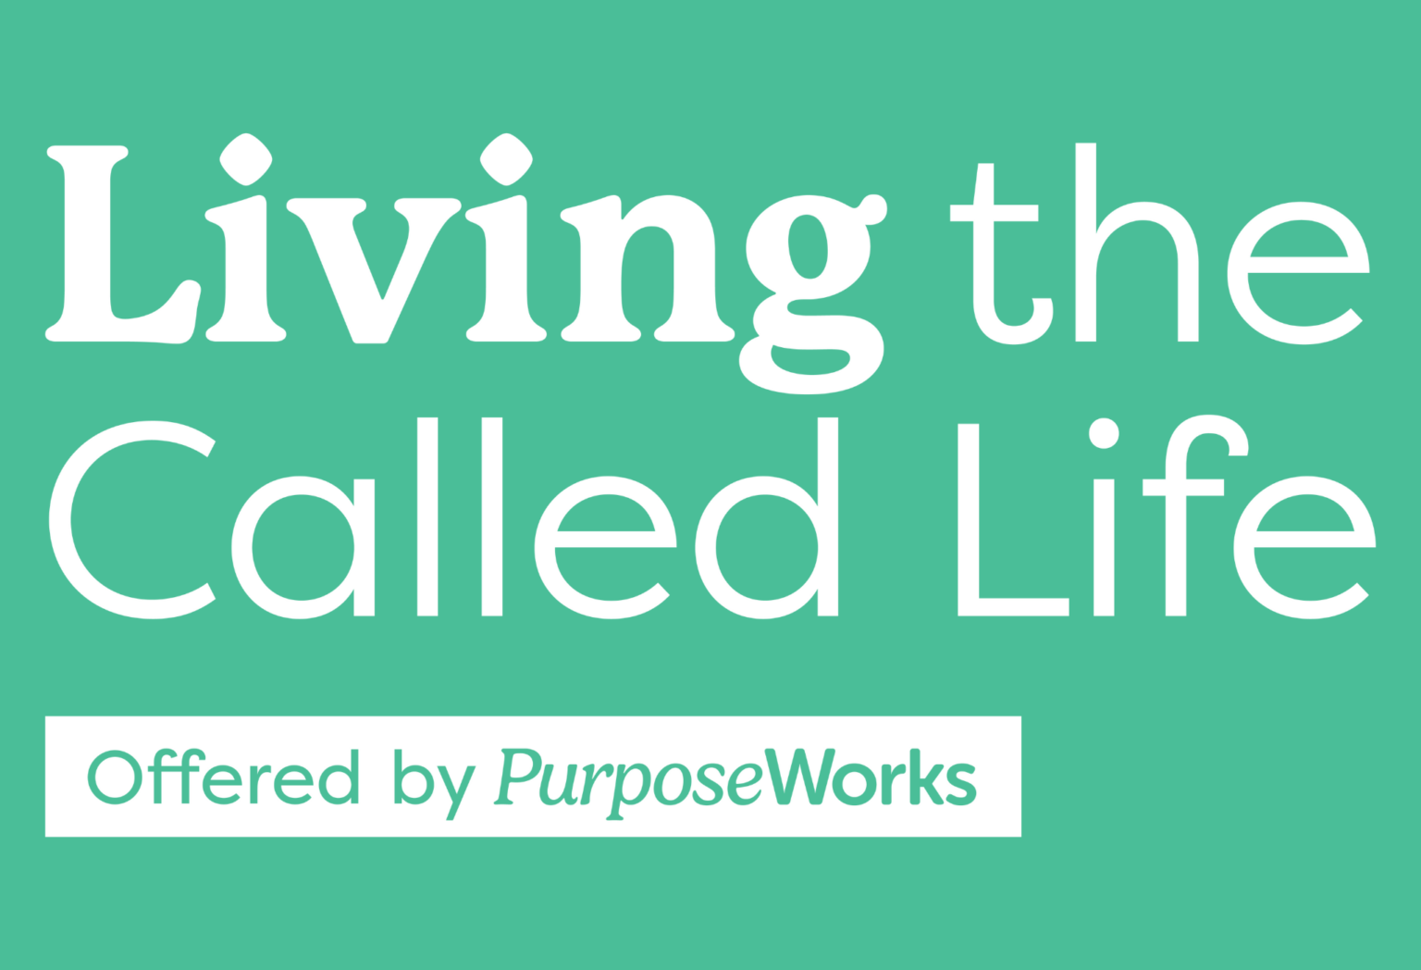
God created you as a Masterpiece to do good works for His kingdom!
No matter what stage of life you are in, God has a mission and calling for you! In this course you will learn why and how God has specifically gifted you and called you to serve Him and His people in ministry and in all areas of your life and practical steps to start.
The task of determining where God has called each of us to serve can be daunting. In “Living the Called Life,” we will walk through practical steps to determine how God has wired you in terms of your spiritual gifts, your strengths, and your passions and help you take the next step in living out God’s calling for you in this season of your life.
Key Outcomes of the Course:
- Learn ways to see where God is working and join Him in your daily life
- Live out God’s mission for you at your current stage in your life
- Write your Life Mission & Purpose Statements
- Pick a life verse - a verse that God uses to speak to you in deep ways.
- Consider the things you should Stop, Start or Continue
- Formally assess your Divine Design and Life Calling Wheel
In Ephesians, we learn that we are God’s handiwork, his masterpiece, created in Christ to do good works. God has uniquely wired each of us to serve in ways He has already set out for us. God has given each of us talents, strengths, and passions, and He desires to use those to further His kingdom where we live, learn, work, and play. In essence, we get to experience increasing joy as we partner with Him to do those good works that bring Him glory and advance His kingdom.
Live out your Masterpiece Mission! Join us and let the journey begin!
Wednesday evenings, {date range}
7:00-8:30 pm, {room/building}

{Church mission/vision statement tie in}

****************OTHER PROMO WORDING*****************************************

Maybe you are part of a church small group or a community group or have a group of friends who want to take it. We have it designed it so that you could all sit together at your own tables (seating for X per table) and all the table discussion each week will still be among your group.

****************
DISCOVER LIFE PURPOSE & BALANCE

Learn practical ways to live out God's calling and experience more joy!

﻿Discover why and how God has specifically gifted you for your good and His glory! God wants to use YOU for His kingdom purposes where you live, learn, work and play.

Key Outcomes:

Write personalized Mission & Purpose Statements and identify your Life Verse
Assess your spiritual gifting and work/life balance
Learn ways to see where God is at work and join Him in your daily life
Consider the things you should Stop, Start, or Continue
Develop a Life Growth Plan

Join us for this 8 session, interactive workshop and learn how to apply these key concepts practically in community!

Consider inviting someone to join you.

Invite your church small group and take the course together.
Share with a friend, colleague, or neighbor.

