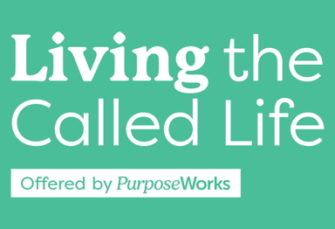
Week 4, Mar. 6, Spring 2025, Lesson Plan
Get Personality Signs up.
7:00-7:02 2min Craig Welcome, Prayer
7:02-7:07 5 min Craig Check In- Big Group, Spiritual Gifts Key-take aways learnings; feedback on websites
7:07-7:14 7 min Craig Divine Design - [A]bilities - Specific Skills, Talents Teaching
7:14-7:34 20 (16.5) min Becky Divine Design - [P]ersonality - DISC Teaching (tie to Animals), Group Exercise
7:34-7:44 10min 3 teaching+ 7 on worksheet. Becky Divine Design - [P]ersonality DiSC profile worksheets – Complete in class -just a couple minutes, Exercises, Applications homework if not finish
7:44-7:52 8min Becky Cohort Discussion on Top 2 Take-aways from Personality
7:52-7:56 3:15 Becky Personality Elevator Video
7:56-8:04 8min Craig Divine Design - [E]xperiences (& Circumstances)
8:04-8:06 2min Craig Show BT and CF samples – Oaks & Box form
8:06-8:16 10min Becky Intro Barbara Praed testimony is confirmed by Craig on 2/4/25
8:16-8:17 1min Becky Homework Review for week 5
8:17-8:19 2min Becky Mission Exploration Spotlight Operations: Connections, Hospitality, Communication, Finance, Prayer, Tech & More
8:19 – 8:42 23min Becky Cohort discussion Experiencing God
8:42-8:45 3min Becky Closing and Prayer
Handout Contents:
- Cover Sheet
- Week 4 Key slides (5-6, 9-13, 17,18, 23), 6 to a page, (including DISC Circles, DHC slide)
- Transferable Adaptive Skills checklist (Only first 3 pages of it)
- DiSC Profile Worksheet - Saved in handouts. Not nec. to be in color.
- Experiences / Life Wins / Struggles Worksheet
- A-Ha Hearing from God Lightbulb Idea Page

