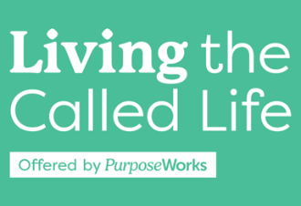
Week 3, Feb. 27, Spring 2025, Lesson Plan
Becky and Craig
7:00-7:01 1 min Becky Welcome, Prayer
7:01-7:3:30 2:30m Becky Divine Design Overview Teaching
7:3:30-7:07 3:30m Becky Introduction to Oaks Worksheet
7:07-7:24 17m Becky Divine Design - [S]piritual Gifts Teaching
7:24-7:25 1min Becky [S]piritual Gifts Key Take-aways Homework
7:25-7:35 10min Becky Cohort Discussion on Spiritual Gifts How Impact Others
7:35-7:39 4min Craig Divine Design –[H]eart Passions Teaching (review from ME sheet)
7:39-7:42 3min Craig Divine Design –[H]eart Teaching on Life Values
7:42-7:54 12min Craig Values Exercise
7:54-7:57 3 min Craig Big Group Discussion on values
7:57-7:59 2 min Craig Divine Design –[H]eart Dreams Teaching Assign (exercise or remind of SHAPE q’s)
7:59-8:00 1min Craig Show Craig and BT samples – Oaks & Box form
8:00-8:01 1min Craig Chariots of Fire Video
8:01-8:18 17 min Craig Craig’s testimony on her life purpose
8:18-8:20 2Min Becky Mission Exploration Spotlight - Care: Divorce, Widow,
Recovery, Financial, Grief & More
8:20-8:21 1min Becky Homework Review for week 4
8:21-8:24 3 min Becky PW/JSN/DF
8:24- 8:41 17 min Becky Cohort Discussion re: book
8:41-8:45 4min Becky Give people time to write out prayer requests. Closing Prayer.
105 Total
Week 3 Handout Contents:
- 1 Cover Sheet
- 2 Week 3 Key Slides 4, 10, 11, 12, 13, 32 (3 per page)
- 3 Oaks of Righteousness Sample
- 4 Oaks of Righteousness Personal Worksheet
- 5 SHAPE Boxes – Life Growth Plan Worksheet
- 6 Spiritual Gifts Take Aways Definitions DHC SHAPE
- 7 Life Values 2022

