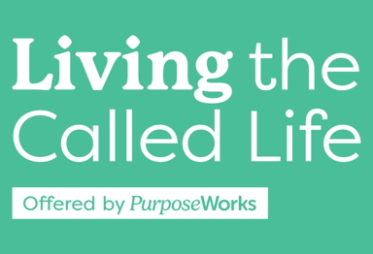
Week 2, Feb. 13, Spring 2025, Lesson Plan
7:00-7:06 6min. Craig Be sure to have group’s attention before starting song! Start 1 min late, Michael W. Smith video, Introduction, Prayer
7:06-7:09 3 min Craig If you think you’ve blown God’s plan, Reminder A-Ha
7:09-7:19 10 min Craig Homework (Book) Check-in table discussion
7:19-7:22 3min Craig Key Terms Defined
7:22-7:24 2min Craig Three Insights into Purpose
7:24-7:31 7min Craig Purpose / Life Purpose Statement
7:31-7:43 12min Craig Life Purpose Statement In-class Work
7:43-7:48 5min Craig Life Purpose Statement Large Group Discussion
7:48-8:09 21min Becky Pursuing a Unique Purpose, Intro to Divine Design-DHC SG; SHAPE
8:09-8:11 2min Becky Mission Exploration Spotlight – Small Groups, Marriage,
Men, Women
8:11-8:21 10min Becky Calling Assignment Check-In – table discussion, share on prayer card
8:21-8:22 1min Craig Homework Review for week 3
8:22-8:26 4min Craig Craig Testimony
8:26-8:27 1min Craig Closing prayer / announcements / Reminder no meeting next week
Handout Contents:
- Cover Sheet
- Week 2 Key Slides (8,13,16, 28,32) Black and White, 6 pages to a page.
- Key Definitions
- Life Purpose Worksheet
- Spiritual Gifts and SHAPE Instructions
- Passions Worksheet

