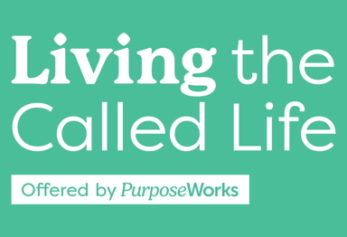
Week 1, Feb. 6, Spring 2025, Lesson Plan
Supplies: Binders & books out, Signs out, Table number tents, Post-its, prayer request sheets, at back: resources – prayers, booklets, other resources, attendance roster.
7-7:04 4 min Everyone get settled, Start late the first week
7:04-7:09 5 min Becky Welcome, Prayer, Staff, Intro (Craig call no shows)
7:09-7:16 7 min Becky Key Questions, Objectives, Weekly Schedule, A-Ha, Definition of Calling
7:16-7:20 4 min Becky Our Calling Is Significant/MLK, insights from class
7:20-7:37 17 min Craig God Calls Every, One Word Intros (12min), God Equips Called, Ordinary
7:37-7:39 2 min Craig Called to Relationship-Not Task, Living for The Line
7:39-7:59 20 min Craig Cohort Discussion
7:59-8:02 3min Becky Where We are Headed – Oaks scripture
8:02-8:07 5min Craig Mission Exploration Defined #1
8:07-8:10 3m Becky Mission Exploration Highlight – Connections, Hospitality, Communications
8:10-8:12 2 minutes extra
8:12-8:23 11m Craig Daily Mission, Amanda, BLESS/FRANC, Intro EG, Homework
8:23-8:28 5 min Craig Satan’s going to attack, Commissioning
8:28 – 8:45 17 min Craig Getting to know each other in Cohort
Total = 105 (2 Built in Cohort times, 2 min buffer)
Handout Contents: (Red = to be finalized)
- Coversheet
- LTCL Course Schedule Spring 2025 with Reading & Homework Syllabus
- Week 1 Key Teaching Points, Scripture & Quotes Slides – 5, 6, 10, 11, 12,13, 15, 16, 19, 26, 31, 32 (12 slides – 4 per page) COLOR
- Mission Exploration Handout
- A-Ha Hearing from God Lightbulb Idea Page

