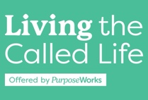 **My Life Growth Plan – Page 1**

**The View from Above- Enduring Truths of my Life Calling**

**MY LIFE VERSE:**

**MY DIVINE DESIGN / S.H.A.P.E.** (key words for each area):

**Spiritual Gifts –**

**Heart (Passions, Values & Dreams) –**

**-Passions -**

**-Values -**

**-Dreams -**

**Abilities –**

**Personality –**

**Experiences –**

**MY LIFE PURPOSE:**

**FRUITS FROM SERVING: FRUITS FROM OTHER LIFE AREAS:**

**MY LIFE MISSION:**