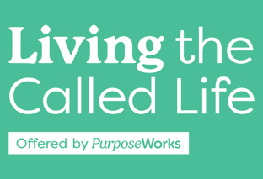

**Life Purpose Statement**

***The Great Commandment***

*Jesus replied: “‘Love the Lord your God with all your heart and with all your soul and with all your mind.’**This is the first and greatest commandment.**And the second is like it: ‘Love your neighbor as yourself.’” Matthew 22:37-39*

***The Great Commission***

*Then Jesus came to them and said, “All authority in heaven and on earth has been given to me.**Therefore go and make disciples of all nations, baptizing them in the name of the Father and of the Son and of the Holy Spirit,**and teaching them to obey everything I have commanded you. And surely I am with you always, to the very end of the age.” Matthew 28:18-20*

**Our Purpose is to Bring Glory to God** by becoming fully formed followers of Jesus:

* **Worshiper:** By worshiping Him motivated by love, thanksgiving and delight, not duty
* **Witness:** By telling others about Him
* **Servant:** By serving others with our gifts
* **Disciple Maker**: Disciple of Jesus Christ and called to disciple others.

Your purpose statement will incorporate the general concepts above worded in a way that brings meaning to you personally. A purpose answers the question, “Why do I exist?” (Note: the specifics of your gifting, circumstances, etc. will come out more in your mission statement.)

**Examples of personalizing a purpose statement:**

*I have brought your glory on earth by completing the work you have me to do. (John 17:4)*

*My passion is to know, love and glorify God, and to be used of Him to raise up workers to help fulfill the Great Commission of Christ.*

*My purpose is to glorify God and serve His people by helping them learn and appreciate His love and design for their lives.*

*My purpose is to know God and make Him known, to worship Him and to encourage others to worship Him.*

*I commit myself, all that I have and will have, all that I am and all that I will become to Jesus Christ, who is not only my Savior, but also my Lord.*

My Life Purpose Statement: