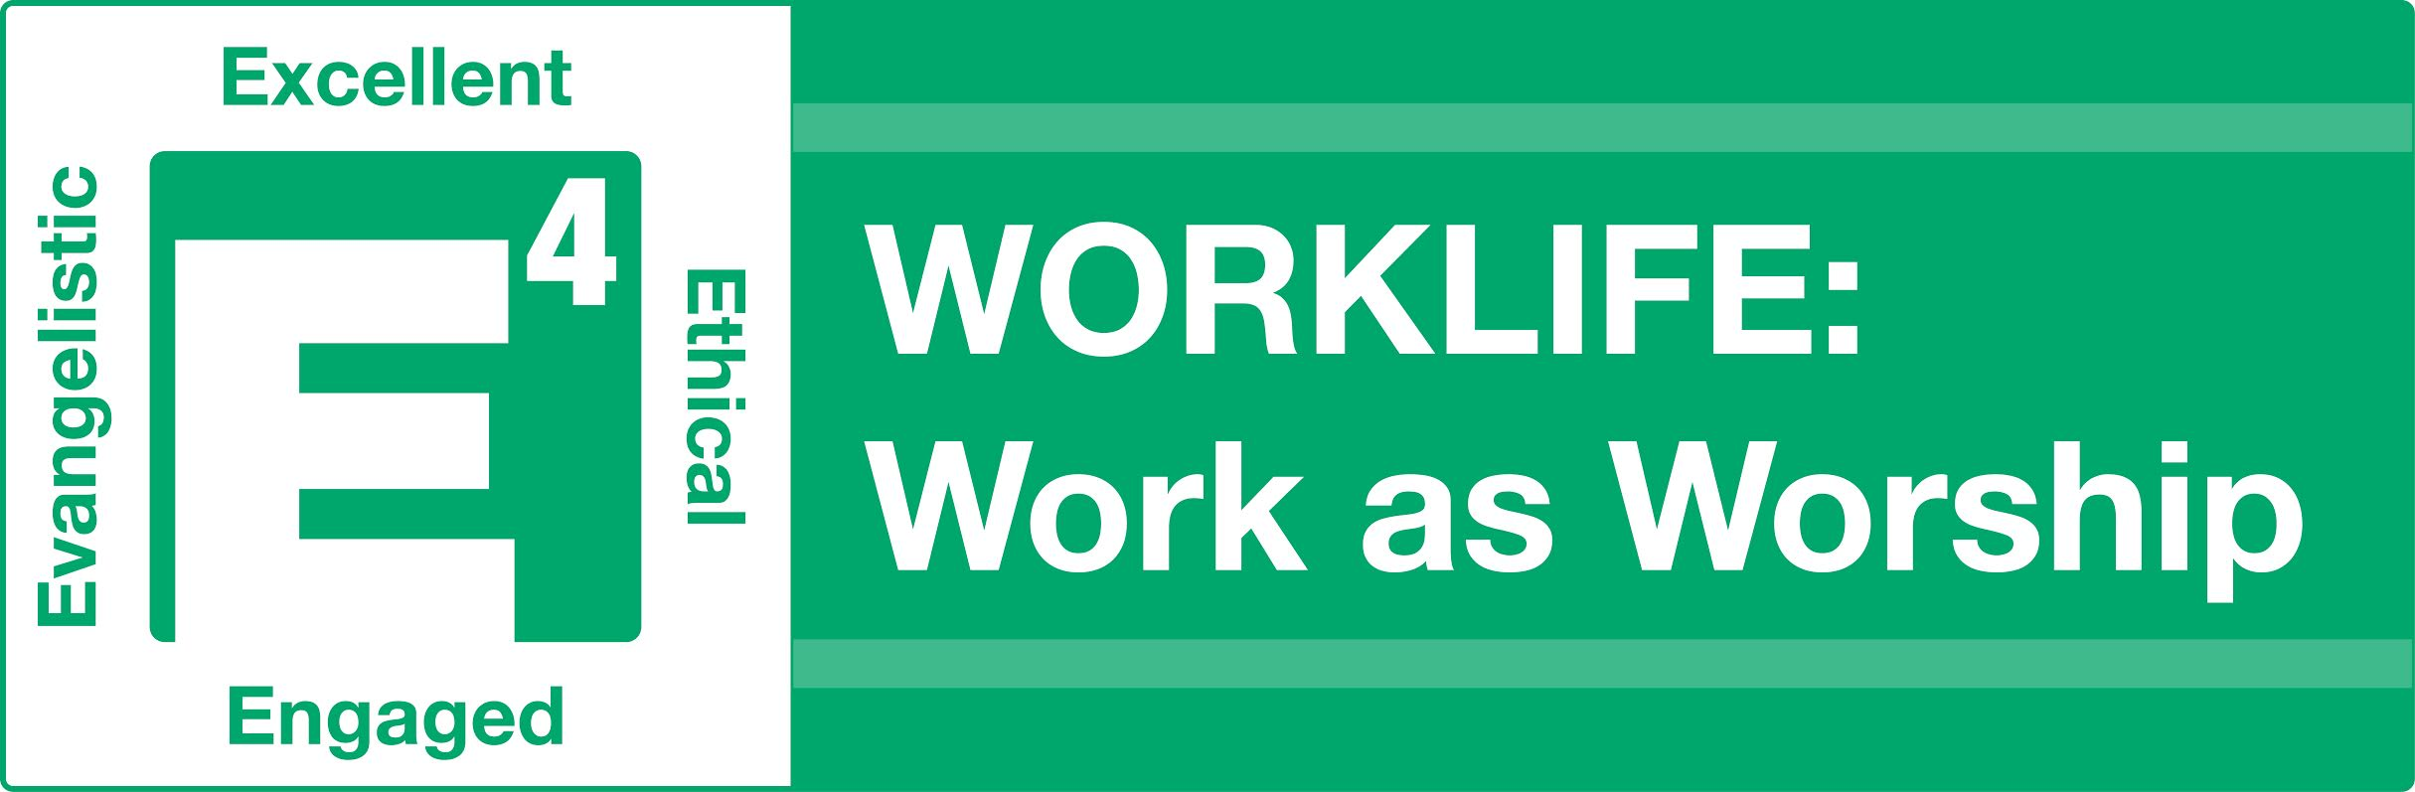

As you listen to each podcast, there are a few things we want you to keep in mind:
- We define “WORKLIFE” or “work life” as: your current job search and then future employment, your current job/employer, or if retired, your current activities.
- Prior to each brown bag lunch, you should listen to two podcasts and complete the listening guide for each. We will use the discussion questions for our time together.
- When the speaker, Pastor Tim Hawks, the Lead Pastor of Hill Country Bible Church Austin since 1989, refers to the WORKLIFE Challenges, we have included them below. You only need to do one. We have added some wording from what Pastor Tim reads to make it applicable if you are currently unemployed. Pastor Tim received his bachelor’s degree from Baptist Bible College in Springfield, MO, and a master’s degree from Dallas Theological Seminary.
- Pastor Tim also refers to a blog, affinity groups and a WORKLIFE website. Instead of those resources, you will be sharing with each other in our discussions to hear great stories, you will be in a small group each session, and we will also be giving you some tools each week.

Session 1 Listening Guide
Podcast 1 - “TAKIN' CARE OF BUSINESS” Selected Scripture
Discovering the origin of work:
Creation is God's work.
Many of the jobs we do today really have their origin in God who was the creator.
God is a __________ and ______________ to work.
We worship and obey God in the Monday through Friday day-to-day activities of our work lives.
Because of ____ there is an ______ or a harshness to work.
God created us as workers (which took place before the fall), and even though it does have an edge and it’s hard, it still has value to God. In fact, Christ came to redeem us from the effects of the curse, not only in our soul, but also in our activity. And in our activity God wants to change our concept of work from something that is a drudgery to something that can be offered to him as a blessing or as an ____ of ______.
Discovering God’s plan for our work.
My effort: __________________ in whatever I’m doing, whatever kind of work I’m in.
That phrase “work at it with all your heart” means that you have an intense focus in your work; you’re paying attention to what you’re doing. It also means that you’re energized by it and you’re bringing energy to it. It’s not something that you’re passive in. And finally, it implies passion. In other words, you care about the product of your day.

My boss: ___________________ not _______
My Paycheck: _______________
Your work ________ to ____.
Discovering God’s principles for work.
- Your work has _________ implications even if it doesn't have apparent eternal value.
- How you _________ at work is as important as where you work.
- How you perform at work is as important as how you ________ at work.
- Putting your heart into your work allows God to _____ your work.
APPLICATION: Take the WORKLIFE Challenge
#1: What was it you liked least about your work or past job? Pray and ask God to give you a new perspective about it, write down what you can do differently and then do it. If job searching, what can you be sure to look for in your new employer to avoid this issue?
#2: Pray for your former company, organization or employer to succeed and prosper, even if you aren’t happy with the way they treated you. If job searching, pray for both your past employer and your next employer to succeed and prosper.

Podcast 2 – “Why Dell & Jesus Should Be Friends” Selected Scripture
KEY VERSE: “Whatever you do, work at it with all your heart as working for the Lord, not for men, since you know that you will receive an inheritance from the Lord as a reward. It is the Lord Christ that you are serving.” Colossians 3:23
As we looked at this passage, we come to understand that we’re not only working for a paycheck, we’re working for eternal reward. We’re not simply working for an earthly boss, we’re working for Jesus Christ Himself. And so how we approach our work and what our work life looks like is really a reflection of our attitude and our faith.

MEET THE E4: __________________________________________
Christian Work Ethic: If Christ followers lived out the principles of work in the Bible, they would be a _________ to every employer. Every employer would consider hiring Christians a benefit and a blessing to their company or their enterprise.

DISCLAIMERS:
Excellence is NOT __________.
When it comes to excellence, everybody has a different __________ because everybody has different __________. (e.g., story of mom with autistic child)
It’s not about __________ the boss. The boss’s view of you is one indicator (and it’s an important one), but it’s not the only one. You need to look at the job requirements, you need to look at the outcomes of what you’re doing, and you need to look at how what you’re doing is impacting the people around you. You should take into account multiple factors to evaluate your performance.
We’re not talking about __________. Part of the nature of risk taking on the job and of innovation is that sometimes you’re going to be assigned to a project that is destined to fail.
Excellence: An __________ that leads to consistent, ____________ performance.
There ought to be a sense where you’re both exhilarated and exhausted in your work. That’s what it means to have an attitude of work. He goes on to say, “work on it with all your heart.” Now your heart is the emotional part that decides. So what Paul’s saying is that you need to own the outcome of your work.
This means you are going to diligently invest your effort, work at it, and do it in such a way that you own that outcome. You work at it with all your heart because it matters to you and that what you do makes an impact. And that leads to consistent, exceptional performance.
____________: The enemy of excellence.
____________: The engine of excellence.
____________: The by-product of excellence.
APPLICATION: Take the WORKLIFE Challenge
#1: Think of a task, a conversation, or anything at work or in your job search you don’t want to do and have been putting off. Pray about it and commit to take care of it this week.
#2: Ask a person who would be in a position to know for feedback on how you handled something at work or in your job search (e.g., how you managed a rejection, how you handled a project, came across in a networking situation, laziness in your job search, etc.) Be willing to listen and apply the feedback, and thank them for their input.

Session 1 Discussion Questions

Icebreaker: What are you really good at? Tell why.

From Podcast 1 - “TAKIN' CARE OF BUSINESS”
- Did Adam and Eve have a job in the Garden of Eden? See Genesis 2:15. What happened to work after they sinned? See Genesis 3:17-19. What are some common attitudes people have today about work?
- How much time do you invest each week in your job or job search? Do you feel that God is interested in these hours?
- Is it what we do for work, whom we work for, where we work or how we our work that matters most to God?
- Discuss each of the following principles (Job Seekers: substitute job search for work or think about it in terms of both your past and future employment situations.):
- Your work has eternal implications even if it has no apparent eternal value.
- How you perform at work is as important as where you work.
- How you perform at work is as important as how you behave at work.
Putting your heart into your work allows God to bless your work.

From Podcast 2 – “Why Dell & Jesus Should Be Friends”
- When you hear the word “Excellent”, what are some of the common images that come to mind (both positive and negative)?

- What would laziness look like in your work life or job search? What are some excuses you could come up with “fun” being lazy? How does that attitude become a “destroyer”? See Prov. 22: 29 (Do you see someone skilled in their work? They will serve before kings; they will not serve before officials of low rank. Proverbs 22: 29)

- What are some things that you need to learn to become excellent in your job or job search? Why is this critical to your success?

- Describe a time when your excellent in job performance gave you a platform of influence with others?

